

**CSE 360: Computer Architecture**

**Section: 3, Summer-2020**

|  |
| --- |
| A Project Report  on  Simulate modern traffic control system |
| Submitted by:  Group: 4  Group Members:  BIPLOP SUTRA DHAR 2017-1-60-121  AMIT ROY 2017-3-60-021  SHEKHOR CHANDRA SAHA 2017-3-60-025 |
| Submitted to:  Nawab Yousuf Ali  Associate Professor, Dept. of CSE |
| Date of Submission:03-11-2020 |

**DEPARTMENT OF COMPUTER SCIENCE & ENGINEERING**

**EAST WEST UNIVERSITY**

1. **Problem Statement**

. Simulate modern traffic control system.

**2. Requirements**

The system on which the project is implemented has the following properties:

Processor: Intel Core i7,3.60 GHz

RAM: 8.00 GB

Operating System: Windows 10, 64-bit

Software: Arduino IDE

Hardware Tools:

1. Arduino Uno
2. Bread Board
3. Led Green (4 Pieces)
4. Led Yellow (4 Pieces)
5. Led Red (4 Pieces)
6. Resister 220 Ohm (12 Pieces)
7. Jumper wire
8. Cock Sheet
9. 9V Dc Battery.

**3. System Design**

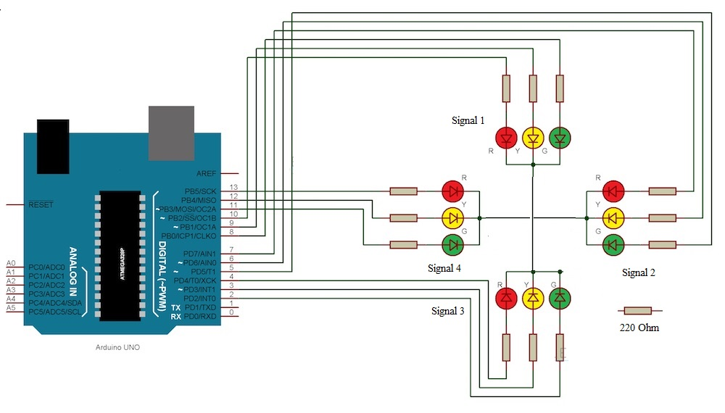

:

**4. Implementation**

int signal1[] = {8, 9, 10};

int signal2[] = {11, 12, 13};

int signal3[] = {5, 6, 7};

int signal4[] = {4, 3, 2};

int greenDelay = 10000;

int yellowDelay = 5000;

void setup() {

// Declaring all the LED's as output

for (int i = 0; i < 3; i++) {

pinMode(signal1[i], OUTPUT);

pinMode(signal2[i], OUTPUT);

pinMode(signal3[i], OUTPUT);

pinMode(signal4[i], OUTPUT);

}

}

void loop() {

//signal 1

digitalWrite(signal1[2], HIGH);// Green

digitalWrite(signal1[0], LOW);// Red

digitalWrite(signal2[0], HIGH);// Red

digitalWrite(signal3[0], HIGH);// Red

digitalWrite(signal4[0], HIGH);// Red

delay(greenDelay);

digitalWrite(signal1[2], LOW);// Green

digitalWrite(signal1[1], HIGH);// Yellow

digitalWrite(signal2[1], HIGH);// Yellow

digitalWrite(signal2[0], LOW);// Red

delay(yellowDelay);

digitalWrite(signal1[1], LOW);// Yellow

digitalWrite(signal2[1], LOW);// Yellow

digitalWrite(signal1[0], HIGH);// Red

//signal 2

digitalWrite(signal2[2], HIGH);// Green

delay(greenDelay);

digitalWrite(signal2[2], LOW);// Green

digitalWrite(signal2[1], HIGH);// Yellow

digitalWrite(signal3[1], HIGH);// Yellow

digitalWrite(signal3[0], LOW);// Red

delay(yellowDelay);

digitalWrite(signal2[1], LOW);// Yellow

digitalWrite(signal3[1], LOW);// Yellow

digitalWrite(signal2[0], HIGH);// Red

//signal 3

digitalWrite(signal3[2], HIGH);// Green

delay(greenDelay);

digitalWrite(signal3[2], LOW);// Green

digitalWrite(signal3[1], HIGH);// Yellow

digitalWrite(signal4[1], HIGH);// Yellow

digitalWrite(signal4[0], LOW);// Red

delay(yellowDelay);

digitalWrite(signal3[1], LOW);// Yellow

digitalWrite(signal4[1], LOW);// Yellow

digitalWrite(signal3[0], HIGH);// Red

//signal 4

digitalWrite(signal4[2], HIGH);// Green

delay(greenDelay);

digitalWrite(signal4[2], LOW);// Green

digitalWrite(signal4[1], HIGH);// Yellow

digitalWrite(signal1[1], HIGH);// Yellow

digitalWrite(signal1[0], LOW);// Red

delay(yellowDelay);

digitalWrite(signal4[1], LOW);// Yellow

digitalWrite(signal1[1], LOW);// Yellow

}

**5. Testing Results**

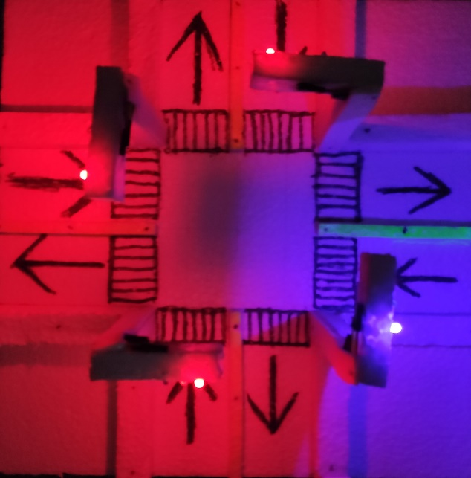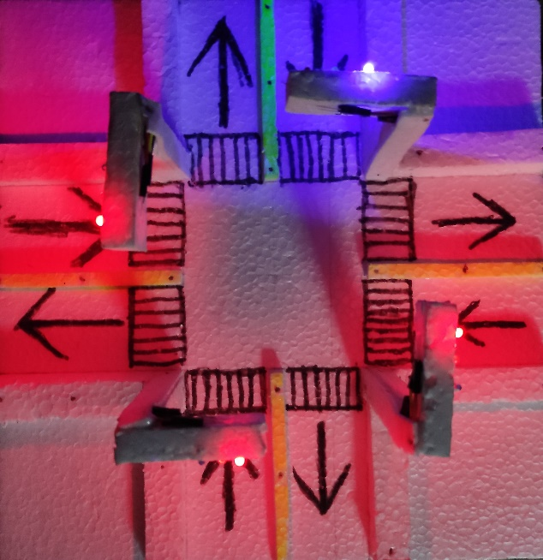

For Signal: 01 For Signal: 02

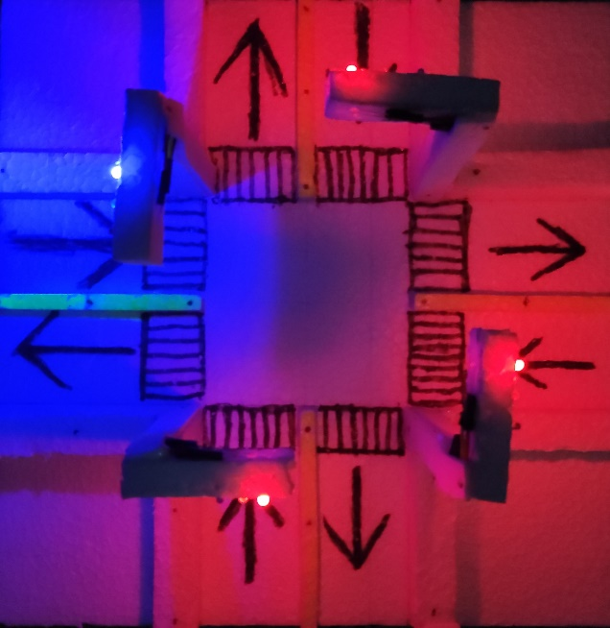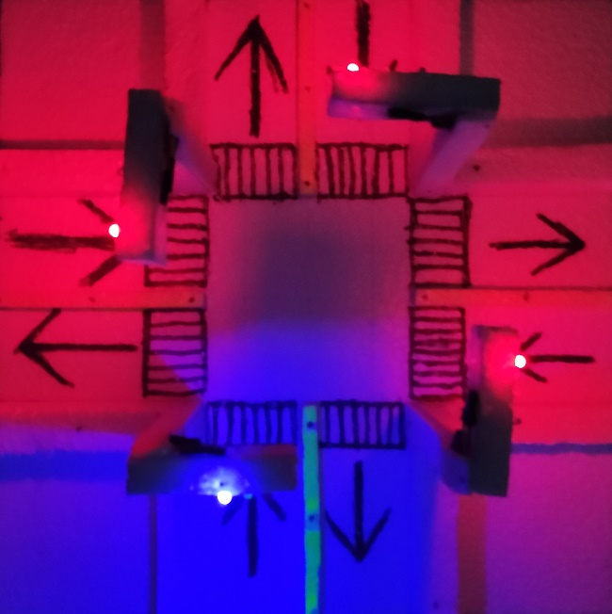

For Signal: 03 For Signal: 04

**6. Future Scope**

* There are some limitations of our project. The first limitation is that the system only works for 4 ways. If increase or decrease ways then it won’t be work. If use it we have to modify the code and some led lights.